Title: **Number Conversion, Math Functions and Logic Diagrams** Test: 6

Course: Introduction to Automation Unit: Introduction to PLC CLO: 4

Name ____________________________ Date ______________

**Objectives**

1. Student shall calculate the correct number conversion base on a number from a different number base system.
2. Student shall draw the output of an instruction given its input(s).

**Assessment**

Students shall demonstrate a comprehension of the objectives listed above by scoring a minimum of 75% on this Test. Grading shall be based on the answer key.

**Instructions**

Calculate the following number to the new number base system given the value from another number base system.

|  |  |  |  |  |  |  |  |  |  |  |  |  |  |  |  |  |  |  |  |  |  |  |  |  |  |  |  |  |  |  |  |  |  |  |  |  |  |  |  |  |  |  |  |  |  |  |  |  |  |  |  |  |  |  |  |  |  |  |  |  |  |  |  |  |  |  |  |  |  |  |  |  |  |  |  |  |  |  |  |  |  |  |  |  |  |  |  |  |  |  |  |
| --- | --- | --- | --- | --- | --- | --- | --- | --- | --- | --- | --- | --- | --- | --- | --- | --- | --- | --- | --- | --- | --- | --- | --- | --- | --- | --- | --- | --- | --- | --- | --- | --- | --- | --- | --- | --- | --- | --- | --- | --- | --- | --- | --- | --- | --- | --- | --- | --- | --- | --- | --- | --- | --- | --- | --- | --- | --- | --- | --- | --- | --- | --- | --- | --- | --- | --- | --- | --- | --- | --- | --- | --- | --- | --- | --- | --- | --- | --- | --- | --- | --- | --- | --- | --- | --- | --- | --- | --- | --- | --- | --- |
| 1. 927410 ______ ______ ______ ______BCD 2. 561210 ______ ______ ______ ______BCD 3. 000111102 _______10 4. 000010112 _______10 5. 5610 ______ ______2 6. 2310 ______ ______2 7. 101110102 _______8 8. 100100112 _______8 | |  |  |  |  |  | | --- | --- | --- | --- | --- | | Truth Table | | | | | |  |  |  |  |  | |  |  |  |  |  | |  |  |  |  |  | |  |  |  |  |  | |  |  |  |  |  | |  |  |  |  |  | |  |  |  |  |  | |  |  |  |  |  | |  |  |  |  |  | |  |  |  |  |  | |  |  |  |  |  | |  |  |  |  |  | |  |  |  |  |  | |  |  |  |  |  | |  |  |  |  |  | |  |  |  |  |  | |  |  |  |  |  | |

|  |  |
| --- | --- |
| 1. 1238 ______ ______2 | 1. 678 ______ ______2 |
| 1. 238 ______10 | 1. 588 ______10 |
| 1. F2A416 ______ ______ ______ ______2 | 1. E20C16 ______ ______ ______ ______2 |
| 1. 1101 0001 1001 11102 _______16 | 1. 1010 1011 1100 11012 _______16 |

Convert the following to the indicated number base.



1. Word _____16
2. Byte _____8
3. Nibble _____10
4. Does this program have rung continuity? Why or why not? Explain in detail.

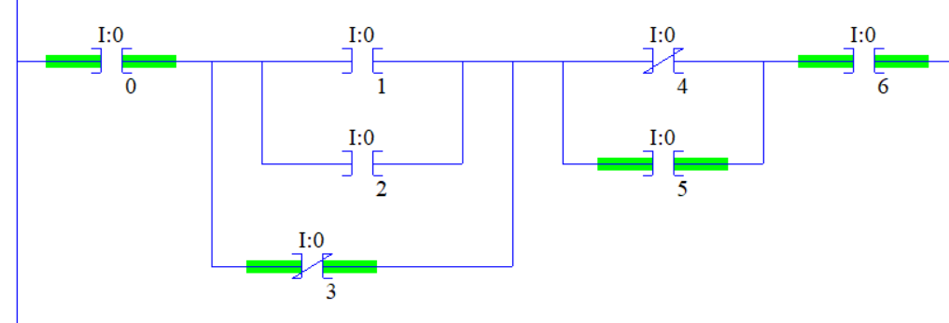

Select the best answer to each multiple-choice question below.

1. An ADD would be used to?
   1. Set a register based on the sum of two numbers
   2. Set a register based on the product of two numbers
   3. Set a register based on the difference of two numbers
   4. Set a register based on the dividend of two numbers
2. A SUB would be used to?
3. Set a register based on the sum of two numbers
4. Set a register based on the product of two numbers
5. Set a register based on the difference of two numbers
6. Set a register based on the dividend of two numbers
7. A DIV would be used to?
8. Set a register based on the sum of two numbers
9. Set a register based on the product of two numbers
10. Set a register based on the difference of two numbers
11. Set a register based on the dividend of two numbers
12. A MUL would be used to?
13. Set a register based on the sum of two numbers
14. Set a register based on the product of two numbers
15. Set a register based on the difference of two numbers
16. Set a register based on the dividend of two numbers
17. When a *motor timer* is done, half of the timer’s accumulative value needs to be stored in an integer register. Explain why the following code is not optimal.

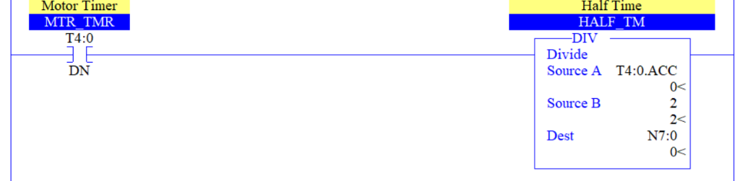

Draw the output to the following logic diagrams.







Draw a sealing start/stop manual motor control circuit using a NC pushbutton, a NO pushbutton, an eight-pin control relay, a green pilot light (running) and a red pilot light (stopped). Label all rungs, wires and terminals. Ensure to include contact cross-references. Control circuit shall be 24VDC and the Motor is 120VAC.

|  |  |  |  |  |  |  |  |  |  |  |  |  |  |  |  |  |
| --- | --- | --- | --- | --- | --- | --- | --- | --- | --- | --- | --- | --- | --- | --- | --- | --- |
| DC Schematic | | | | | | | | | | | | | | | | |
|  |  |  |  |  |  |  |  |  |  |  |  |  |  |  |  |  |
|  |  |  |  |  |  |  |  |  |  |  |  |  |  |  |  |  |
|  |  |  |  |  |  |  |  |  |  |  |  |  |  |  |  |  |
|  |  |  |  |  |  |  |  |  |  |  |  |  |  |  |  |  |
|  |  |  |  |  |  |  |  |  |  |  |  |  |  |  |  |  |
|  |  |  |  |  |  |  |  |  |  |  |  |  |  |  |  |  |
|  |  |  |  |  |  |  |  |  |  |  |  |  |  |  |  |  |
|  |  |  |  |  |  |  |  |  |  |  |  |  |  |  |  |  |
|  |  |  |  |  |  |  |  |  |  |  |  |  |  |  |  |  |
|  |  |  |  |  |  |  |  |  |  |  |  |  |  |  |  |  |
|  |  |  |  |  |  |  |  |  |  |  |  |  |  |  |  |  |
|  |  |  |  |  |  |  |  |  |  |  |  |  |  |  |  |  |
|  |  |  |  |  |  |  |  |  |  |  |  |  |  |  |  |  |
|  |  |  |  |  |  |  |  |  |  |  |  |  |  |  |  |  |
|  |  |  |  |  |  |  |  |  |  |  |  |  |  |  |  |  |
|  |  |  |  |  |  |  |  |  |  |  |  |  |  |  |  |  |
|  |  |  |  |  |  |  |  |  |  |  |  |  |  |  |  |  |
|  |  |  |  |  |  |  |  |  |  |  |  |  |  |  |  |  |
|  |  |  |  |  |  |  |  |  |  |  |  |  |  |  |  |  |
|  |  |  |  |  |  |  |  |  |  |  |  |  |  |  |  |  |
|  |  |  |  |  |  |  |  |  |  |  |  |  |  |  |  |  |
|  |  |  |  |  |  |  |  |  |  |  |  |  |  |  |  |  |
|  |  |  |  |  |  |  |  |  |  |  |  |  |  |  |  |  |
|  |  |  |  |  |  |  |  |  |  |  |  |  |  |  |  |  |
|  |  |  |  |  |  |  |  |  |  |  |  |  |  |  |  |  |
| AC Schematic | | | | | | | | | | | | | | | | |
|  |  |  |  |  |  |  |  |  |  |  |  |  |  |  |  |  |
|  |  |  |  |  |  |  |  |  |  |  |  |  |  |  |  |  |
|  |  |  |  |  |  |  |  |  |  |  |  |  |  |  |  |  |
|  |  |  |  |  |  |  |  |  |  |  |  |  |  |  |  |  |
|  |  |  |  |  |  |  |  |  |  |  |  |  |  |  |  |  |
|  |  |  |  |  |  |  |  |  |  |  |  |  |  |  |  |  |
|  |  |  |  |  |  |  |  |  |  |  |  |  |  |  |  |  |